**1-Exploratory Test-Regression test, Functional Test-Performance Check-Security Check-Usability check**

|  |  |  |  |  |  |
| --- | --- | --- | --- | --- | --- |
| **Exploratory Test** | **Regression Test** | **Functional Test** | **Performance Check** | **Security Check** | **Usability Check** |
| **A** type of testing where testers check system on the fly. They may note down ideas about what to test before test execution (It is a simultaneous process of test design and test execution all done at the same time). | **A** type of software testing to confirm that a recent program/ code change has not adversely affected existing features.   * Is done to make sure that new code changes should not have side effects on the existing functionalities. | **A** type of testing that verifies that each function of the software application operates in conformance with the requirement specification mainly involves black box testing, and it is not concerned about the source code of the application.   * Involves checking of User Interface, APIs, Database, security, client/ server applications and functionality of the Application Under Test (either manually or automation) | **A** type of software testing to ensure software applications will perform well (Like: response time, reliability, resource usage and scalability) under their expected workload   * Checking a software program's: Speed (whether the app responds quickly), Scalability (max user load the app can handle), and Stability (if the app is stable under varying loads) | **A** type of Software Testing that ensures software systems and applications are free from any vulnerabilities, threats, risks that may cause a big loss   * Finding all possible loopholes and weaknesses of the system which might affect the Organization. So the system does not stop functioning or is exploited. | **A** type of software testing where, a small set of target end-users, of a software system, "use" it to expose usability defects.   * Focuses on the user's ease of use the application, flexibility in handling controls and the ability of the system to meet its objectives (User Experience UX) |

**2- ماهي الخطوات لبدء اختبار اصدار جديد من اي نظام؟**

**3- ما هو UAT User Acceptance Test وما هو اهميته ومكوناته ؟**

|  |  |  |  |
| --- | --- | --- | --- |
| A type of testing performed by the Client to certify the system with respect to the requirements that were agreed upon (in the final phase of testing) | |  |  | | --- | --- | |  | **What is it?** | |
| To validate the end to end business flow. It does NOT focus on cosmetic errors, Spelling mistakes or System testing. It is carried out in a separate testing environment with production-like data setup | **Importance?** |
| * Analysis of Business Requirements * Creation of UAT test plan * Identify Test Scenarios * Create UAT Test Cases * Preparation of Test Data (Production like Data) * Run the Test cases * Record the Results * Confirm business objectives | **components** |

**4- بعد الانتهاء من عمل اختبار لنظام يتطلب تسليم Exit Report اذكر محتويات هذا التقرير؟[2]**

**5- اختار موقع او تطبيق وقم بعمل الاختبار المناسب واكتب الاخطاء التي ستجدها على الشكل التالي:**

**Defect Example:   
Summary (it's like a title for the defect): Login - Forget password - by Email.  
Description: When try to reset the password by email, the Link is not open when received email.  
Platform( Web, Android, iOS).  
Priority:(Critical, High, Medium, Low).  
Type(Bug, Business bug, Usability problem, Performance problem, Cosmetics, Enhancement).  
Screenshot**

[1]*Guru99.com*, 2019. [Online]. Available: https://www.guru99.com/software-testing.html. [Accessed: 05- Aug- 2019].

[2]"Test Summary Report |Professionalqa.com", *Professionalqa.com*, 2019. [Online]. Available: http://www.professionalqa.com/test-summary-report. [Accessed: 05- Aug- 2019].

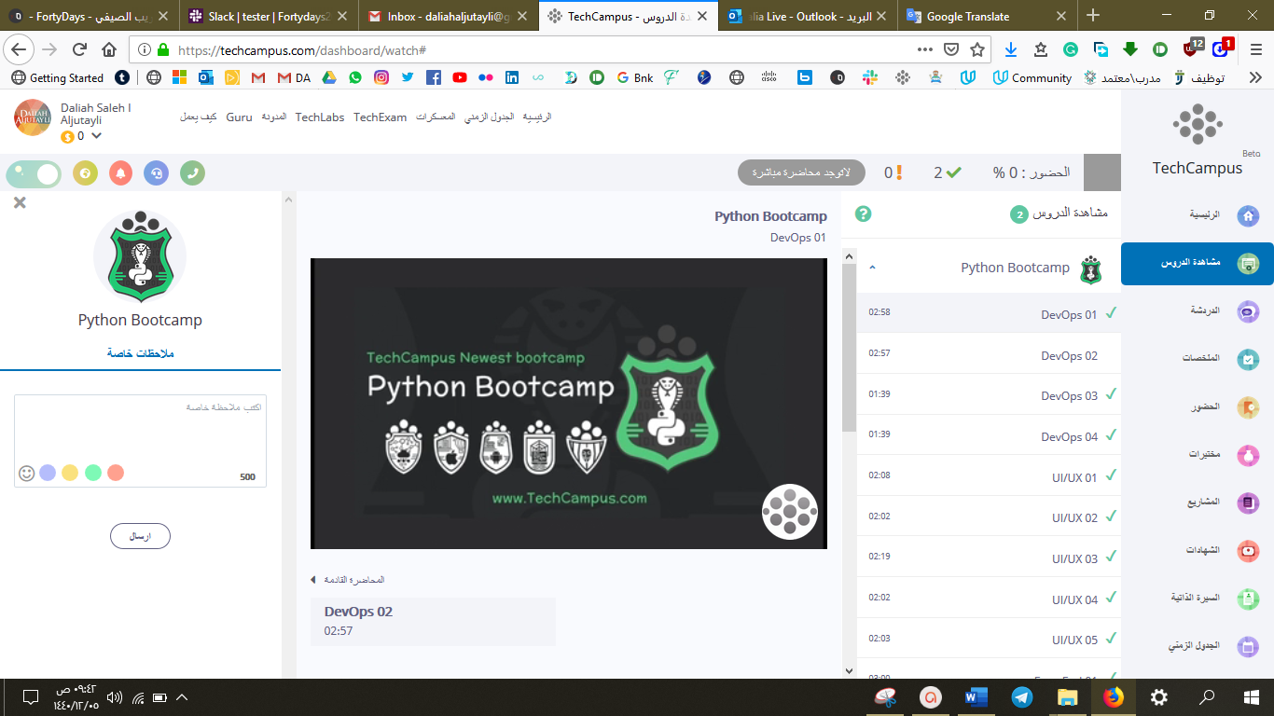

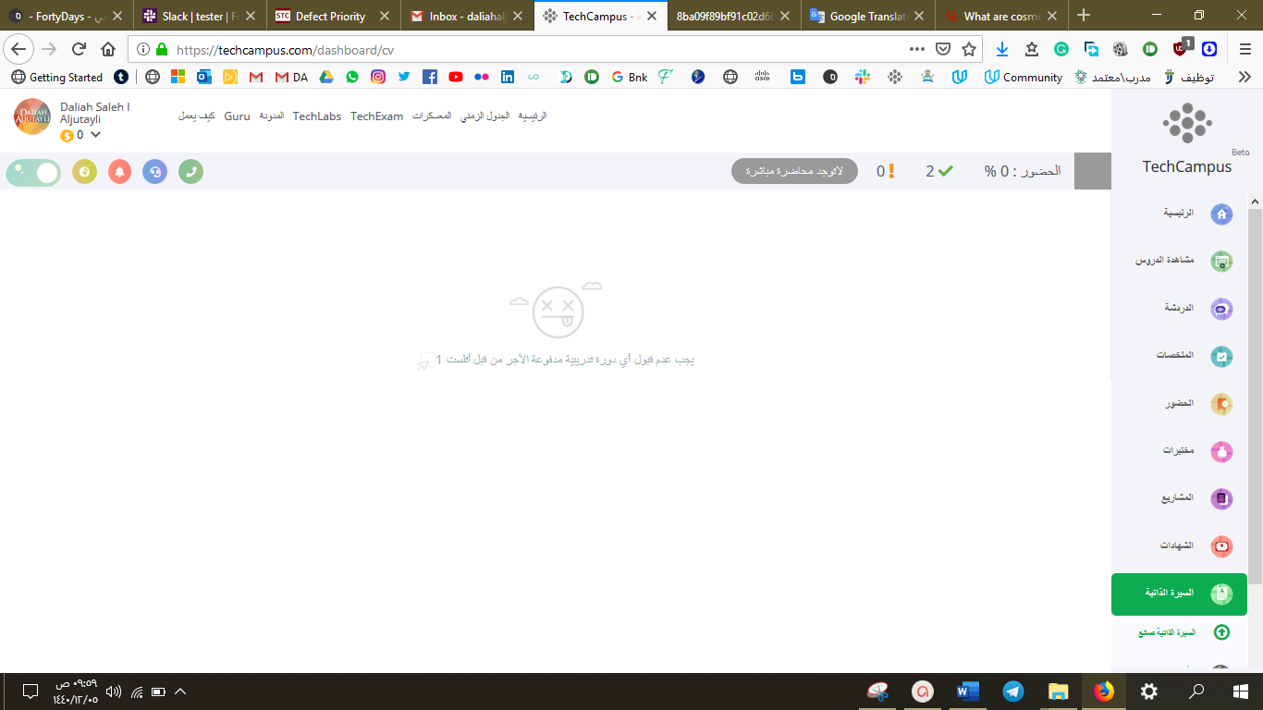

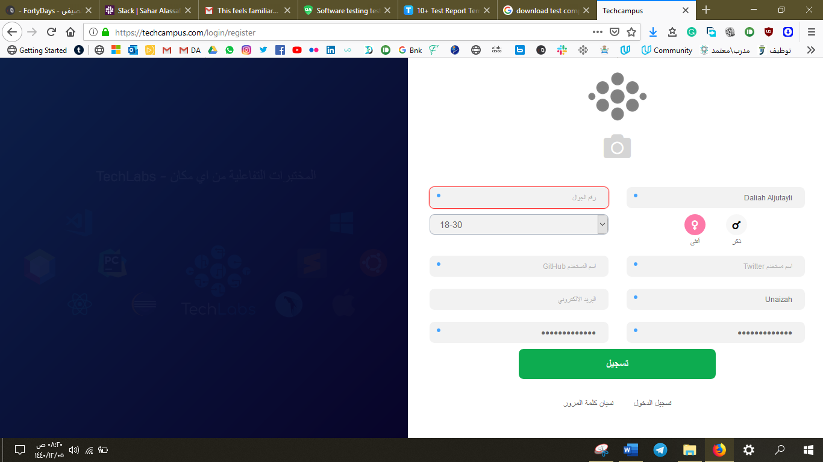

Daliah**#123456**

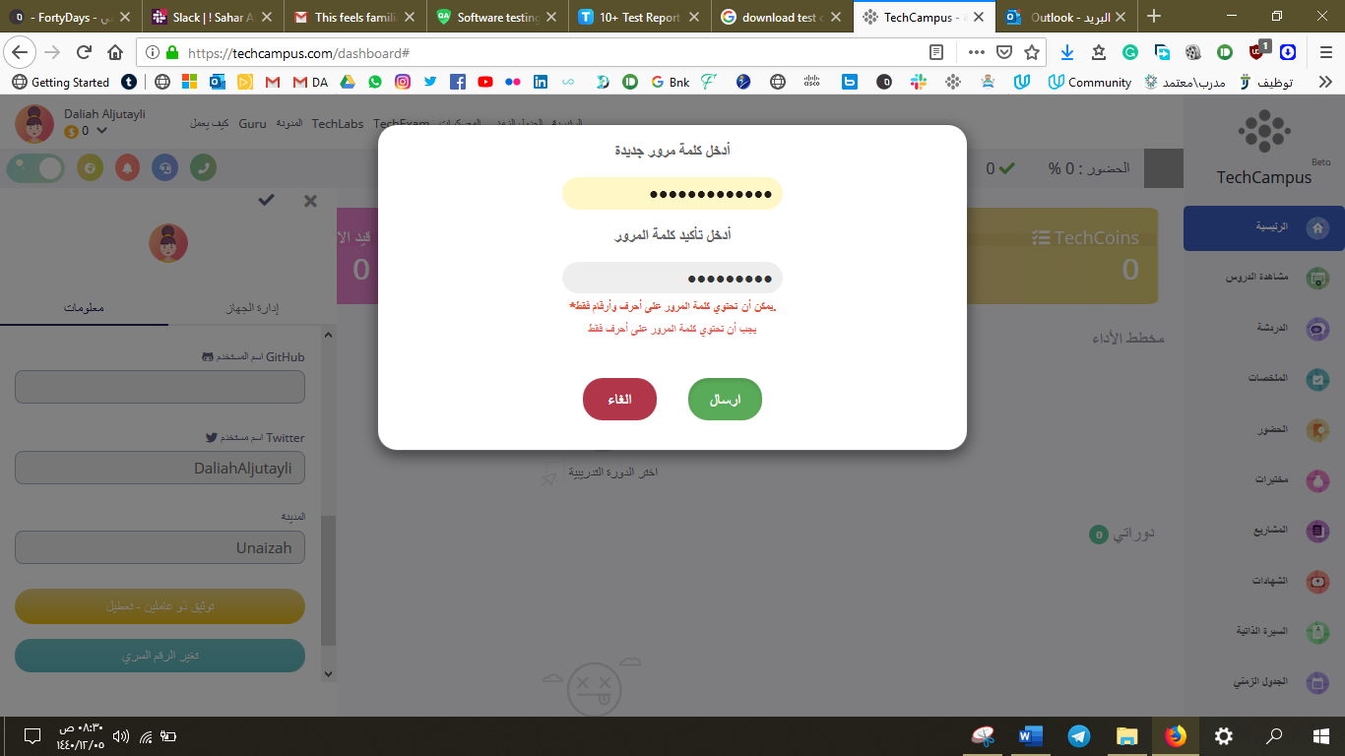

Daliah**$#@**

**ادخال كلمة المرور الجديدة:**

**Daliah$#@**

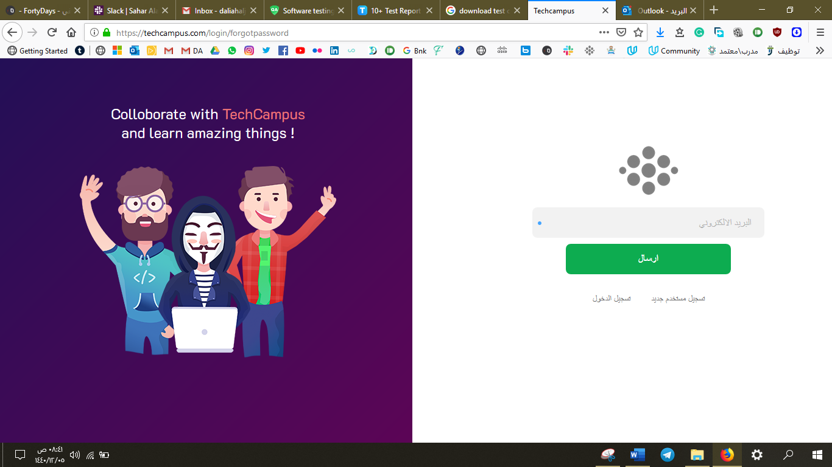 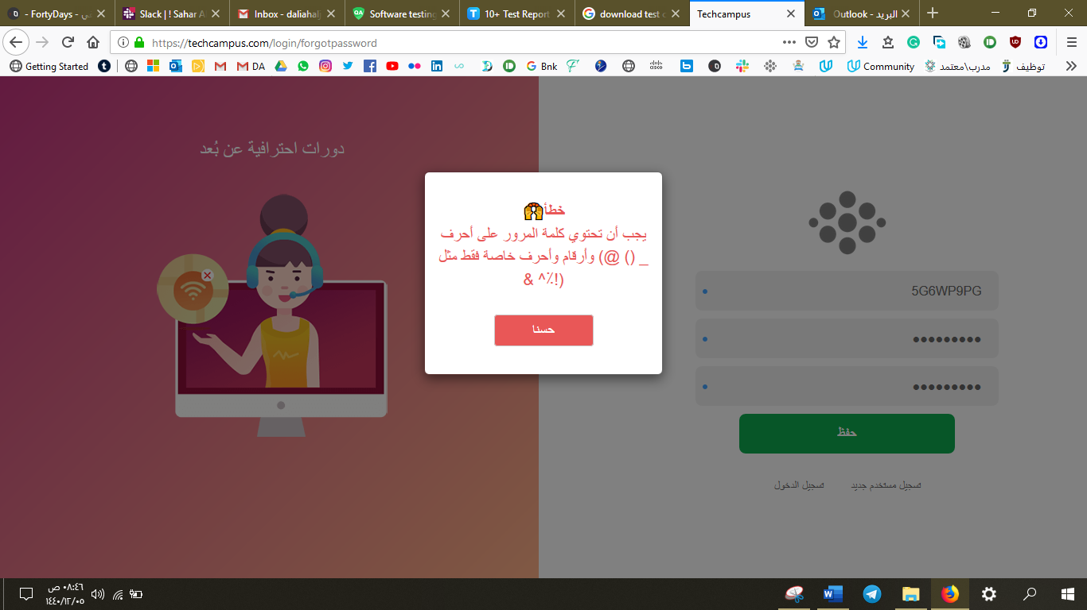

**نسيان كلمة**

**المرور**

